|  |
| --- |
| Project report    on |
| **OPEN BANK** |
| Bank Application |
| C:\Users\ROHIT\Desktop\Uni.jpg |
|  |
| * **Name: Rohit Pravin Sapkal** * **Course: Datascience For Business** * **Subject: Mobile Finance Application** |

|  |
| --- |
|  |

* **Teachers:**

1. Dr.Mario Kolberg
2. Dr. Petric Maier

**List of Contents**

* **Introduction**
* **Task Details**
* **App Description**
* **Cordova based Financial Application**
  + **Working of Open Bank Project**
  + **Use of Cordova Global Statistics’**
* **Languages Used for Application**
  + **JavaScript**
  + **JQuery**
  + **HTML**
  + **CSS**
* **Cordova Project Workflow**
* **Use Case Details**
  + **Selected Login Details**
  + **Selected Bank Details**
* **Process Execution Flow** 
  + **First Step : Open Bank Login Page**
  + **Second Step: Query Bank**
  + **Third Step: List of Bank**
  + **Fourth Step: Account Id**
  + **Fifth step: Transection Details**
* **Platforms**
* **Browser**
* **Android**
* **Conclusion**
* **References**
* **Code Snippet**
  + **JavaScript Script**
  + **HTML Script**
  + **CSS Script**

**Introduction**

**What is development?**

Programmer writes some code for new tech device like mobile phones which make user satisfied with the mobile application. This application may be pre-installed or downloaded by the customer from play store for android and app store for IOS or from other mobile software platforms.

It is depend on various platforms like android or IOS as well as priority of that platforms which is most usable according to the requirements.

**Mobile Application General Workflow**

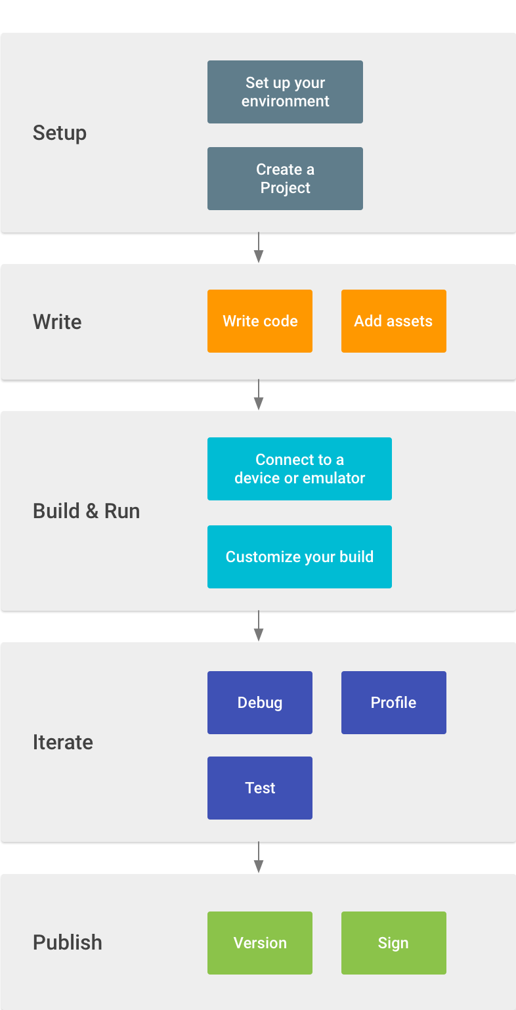

**Task Details**

Making of Cordova open bank application which retrieves the entire bank names and transection details in which our selected user has an account doing this using open bank project platform which will help to collect the dummy username and password. Using this platform we are able to collect all the information that we need for the application building like Account ID, customer ID and many more. Moreover, we can make collect consumer key which is required for calling this username, password and other details in the form of API.

**App Description**

My application name is open bank in this I will able to retrieve entire details of my selected user

For instance, all the bank name which my user has an account, account ID and selected bank transection details like date, description, balance etc.

Basically, this is my open bank mobile application which I am going to run in browser for better understand and also in android platform too but in android platform chrome special link is not working so that my login always show failure because it is not able to collect the token which is provided by open bank platform.

**Cordova based Financial Application**

* + **Working of Open Bank Project**

Open Bank Project is an open-code API and an app store that allows financial institutions to make use of the talent and development of third parties to improve their customer products and services.

This API provides a consistent technical interface for all the programmers and secures space for the creation of the latest services at the highest end of every bank or financial organization. It’d be thought that this scenario would vastly increase insecurity and thus the shortage of customer privacy, but this is often never the case

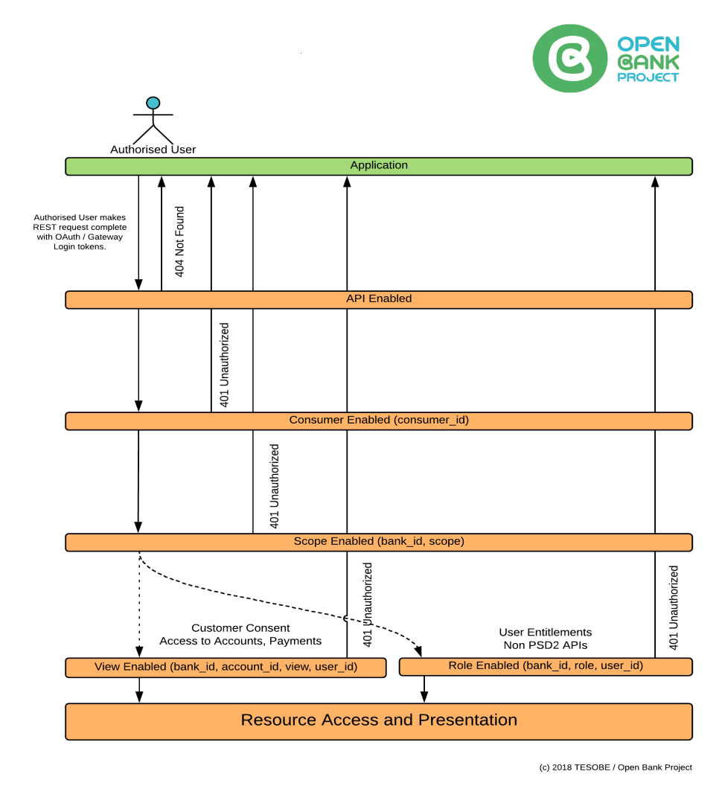

* + **Use of Cordova graph**

**The following graph shows that 29% Cordova platform is used for various application in various industries.**

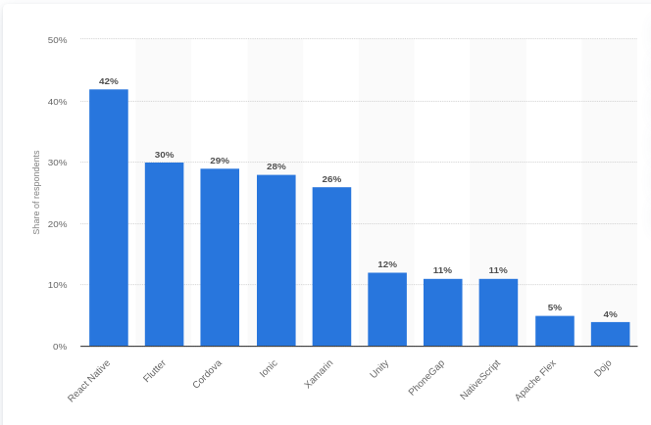

**Languages use for Cordova application**

* + **JavaScript**

JavaScript is a programming language which used for web design or it also known as backend programming language. This language is easy to understand and had a lot of plugin which will help to minuses developer coding line and help them to improve UI because this language also support frontend frameworks like angular, css, html

This programming language is also used in client side development as well as server side development. JavaScript is hold the capability of both interpreted as well as objects oriented language. it helps developer to develop interactive front-end also JavaScript used for mobile application development, desktop application, and games.

* + **JQuery**

JQuery is the JavaScript library which will help developer to write less and expect more from code or it also help to understand source code for any person in the other world more flexible code for reading.

* + **HTML**

It is the frontend programing language which used for designing web or mobile application moreover it tell the UI how to display the content which is write in HTML using lot of syntax like h1,title,div and many more.

* + **CSS**

CSS also the frontend programing language used to design attractive UI moreover it use tell the appearance of text which is write in HTML. It makes UI User-friendly as well as easy to use because it is responsive and attractive.

**Cordova Project Workflow**

**Or**

**Architecture**

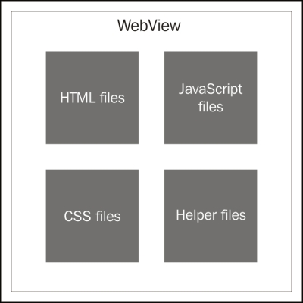

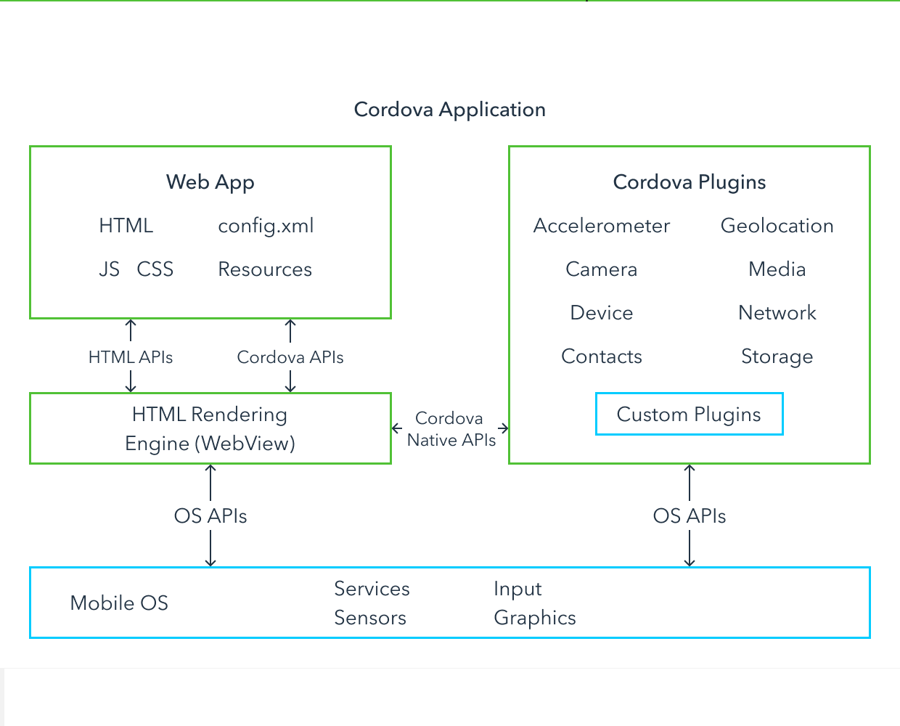

**Use Case Details**

There are many banks available for my selected user like The Royal Bank Of Scotland, Test Bank, Testowy Bank, Nordea Bank AB, Hongkon and Shanghai bank, Deutche Bank Test, The Indian Bank X, Banco Pastor, de, fi, be, it, and many more.

**Selected Login Details**

* + Email ID: jaakko.fi.29@example.com
  + Password : 8132cf
  + Username: jaakko.fi.29@example.com

**Selected Bank Details**

* + Bank Name : fi
  + Short Name : FI
  + ID : gh.29.fi
  + Account ID : *28aa4e5c-c89f-45d9-8b06-946f42d3ac0a*

*9c0502d7-c076-424d-a2bc-cb689edb4734*

**Process Execution Flow**

**First Step : Open Bank Login Page**

Following image shows that login page UI and how it look like

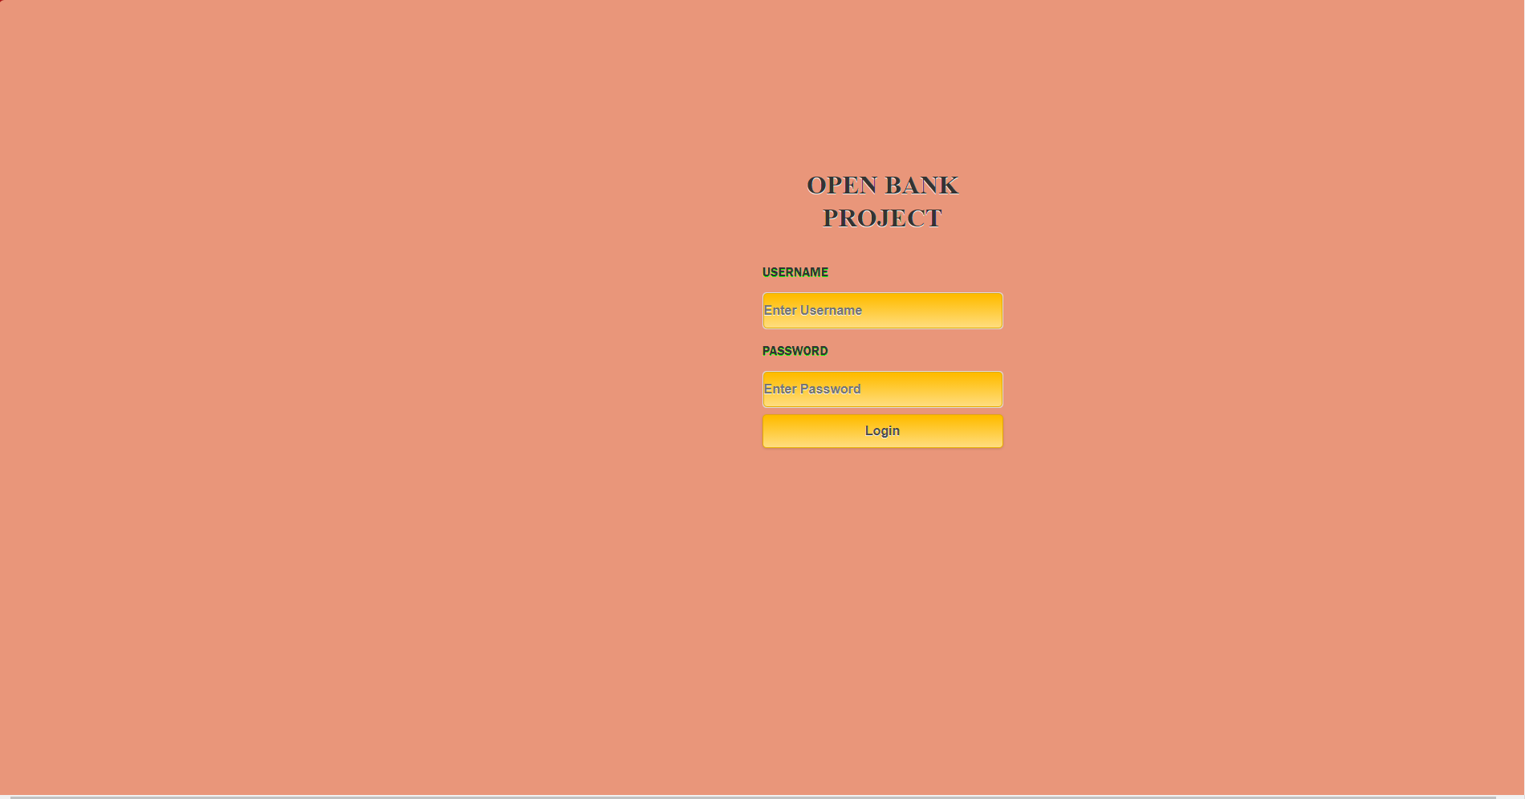

Save Login page

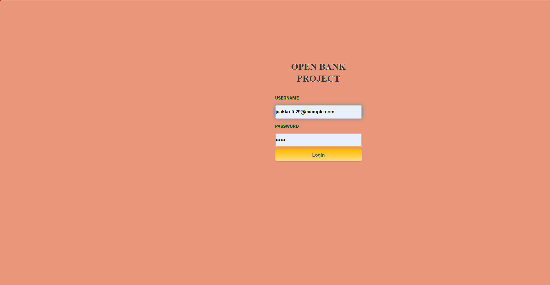

Success full login

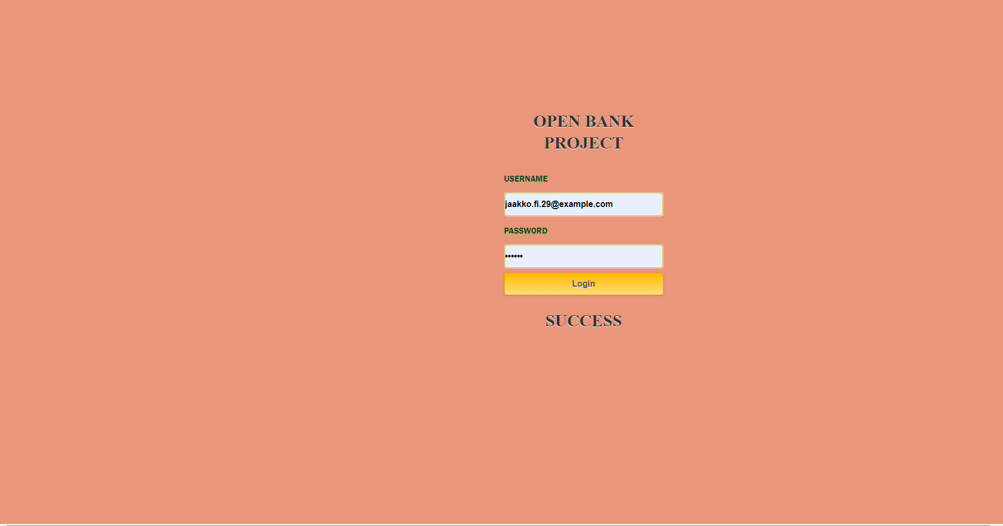

**Second Step: Query Bank**

After Success full login we render to page 2 which is Query Banks here it collect token after pressing this button and show all banks Names, IDs, Short name.



**Third Step: List of Bank**

In this step we see all bank name in which my selected user has an accounts.

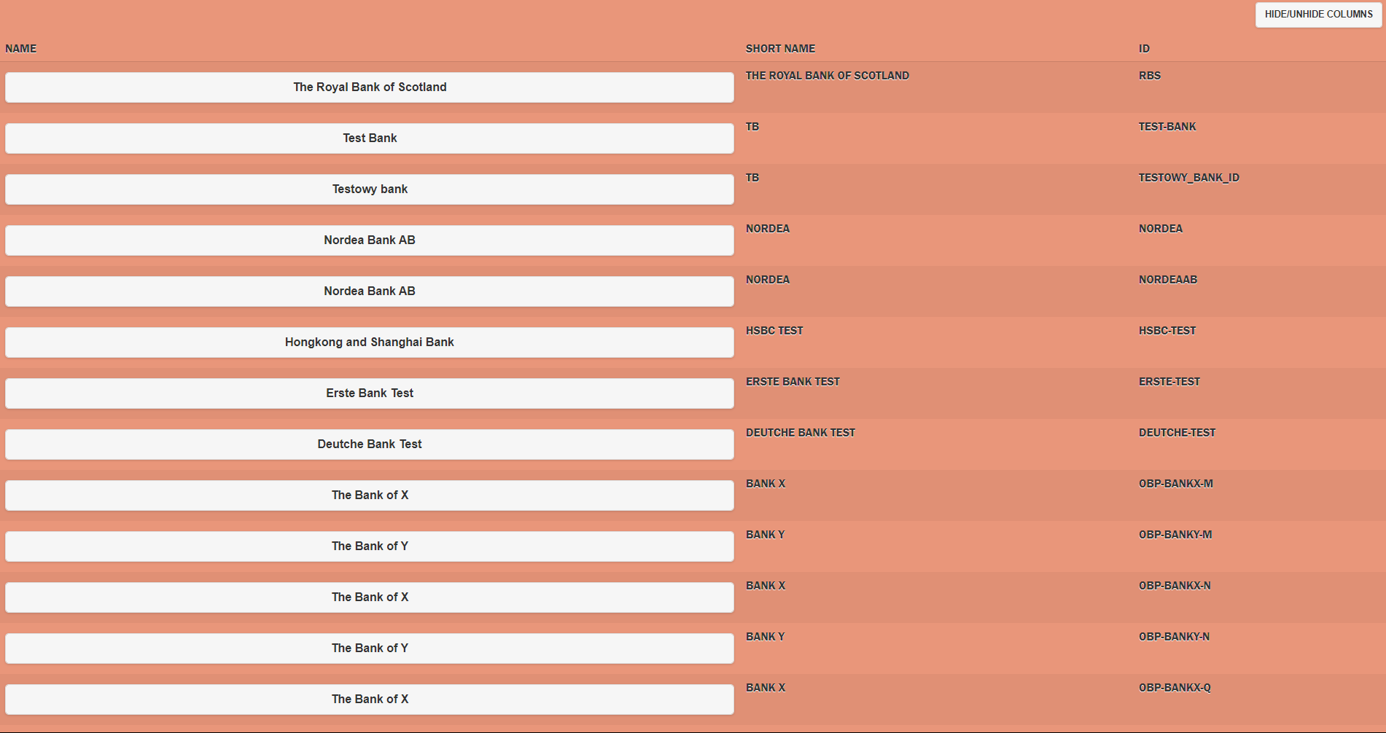

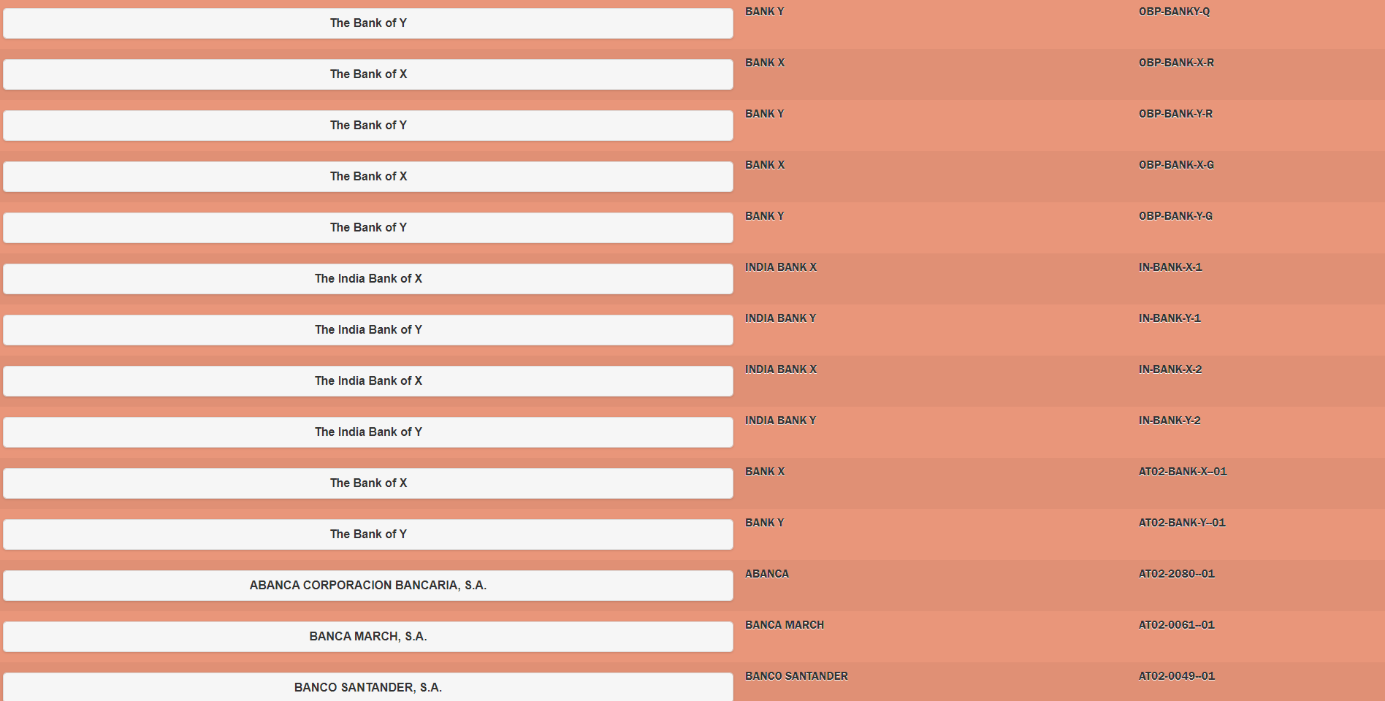

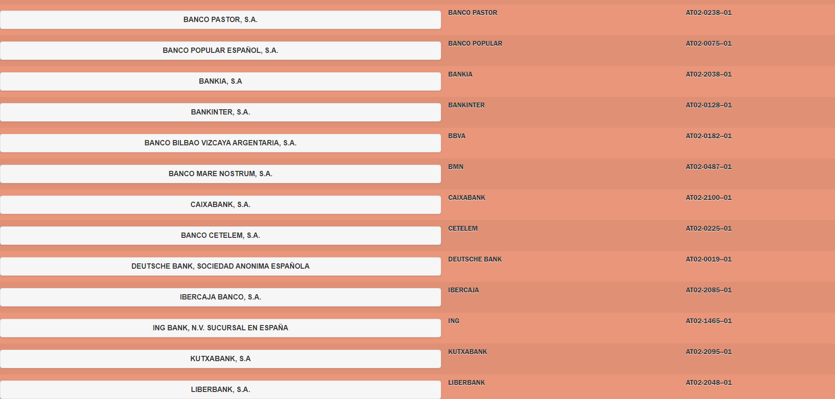

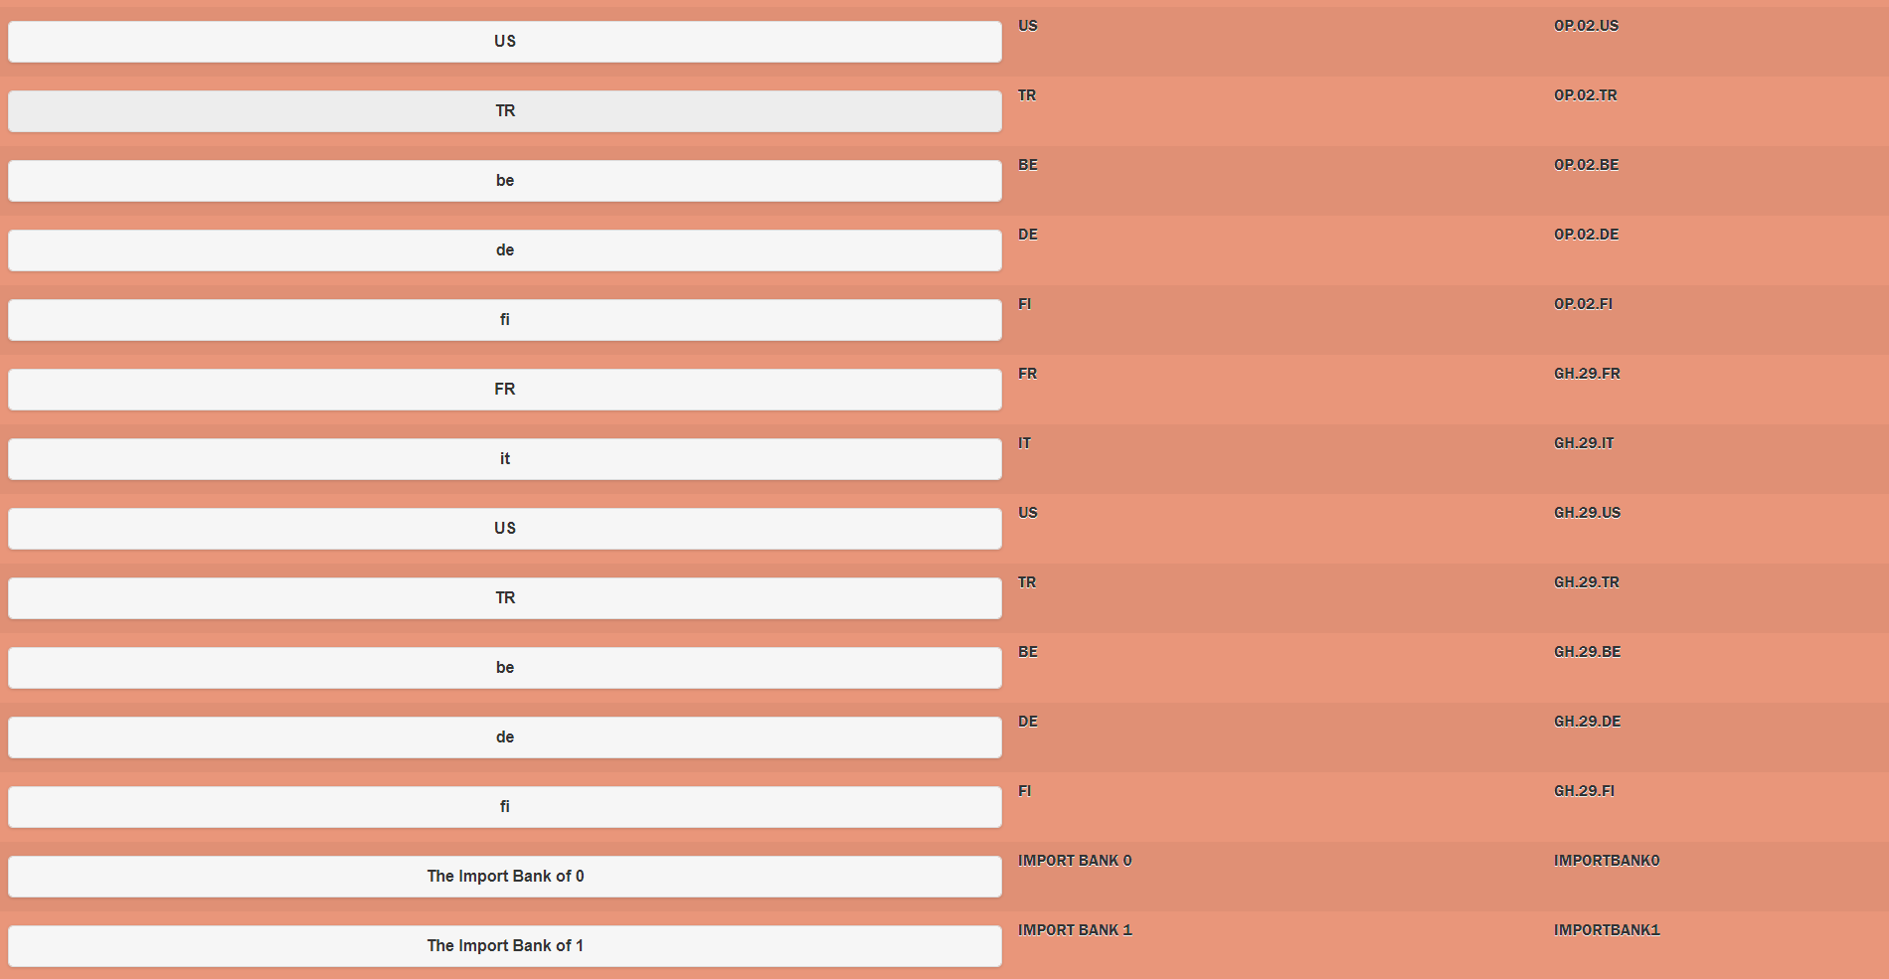

**Fourth Step: Account Id**

Here we see Account Ids for my selected user

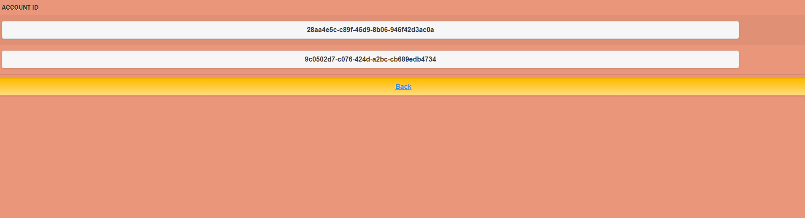

**Fifth step: Transection Details**

In this Step we see Transection details of my user

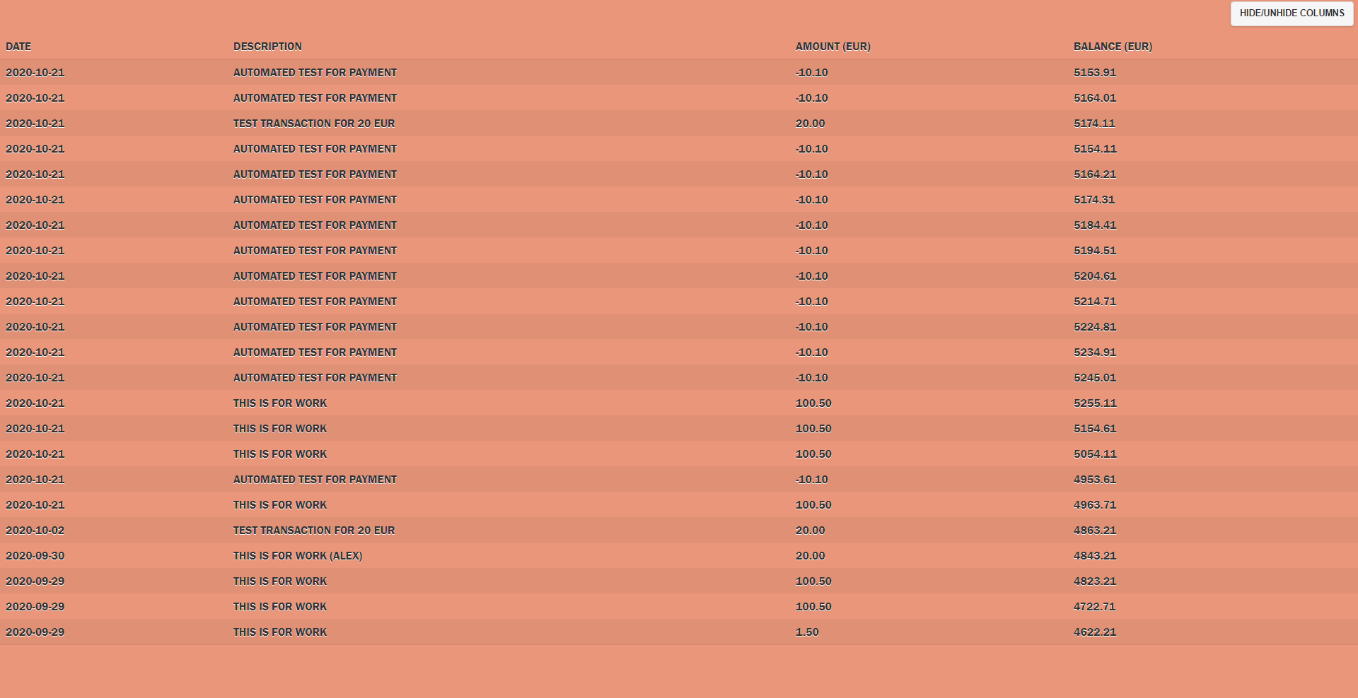

**Platforms**

In this Application I used two platforms which is as follow

**Browser:**

Browser is the good practice for learner to use is our code is running good or bad moreover is there any error is shown or not.

**Android:**

This platform is exactly same as mobile if we run our code best or it show us the exact look of how it look in our android phone which may also called it stimulator.

**Failure Case**

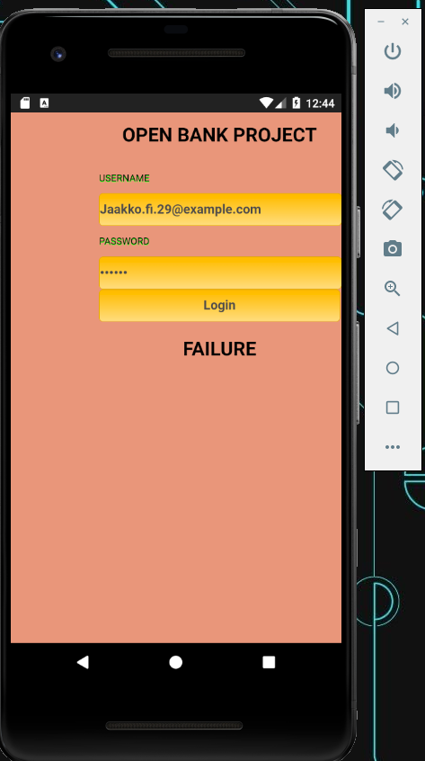

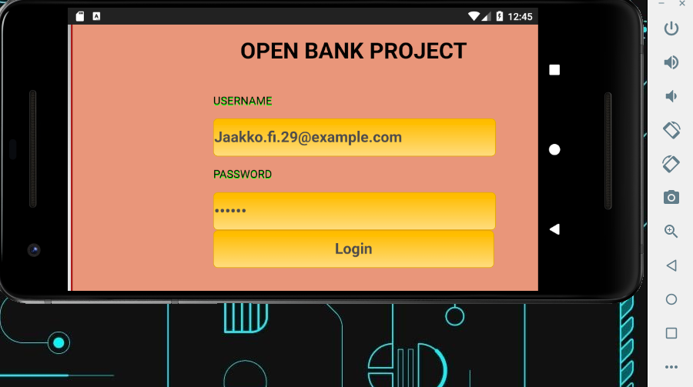

**Luckily it working**

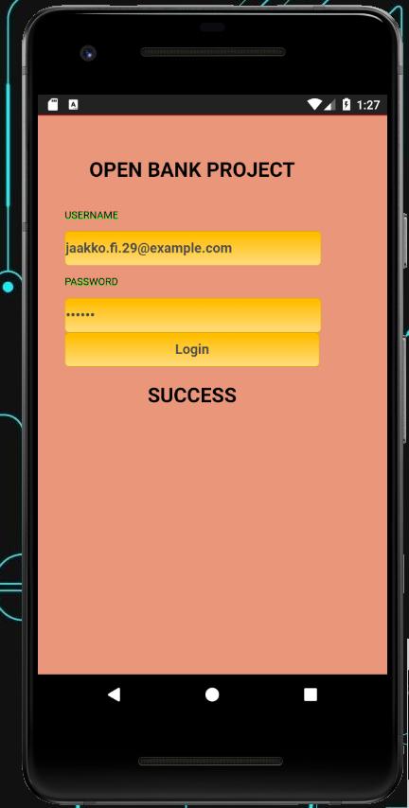

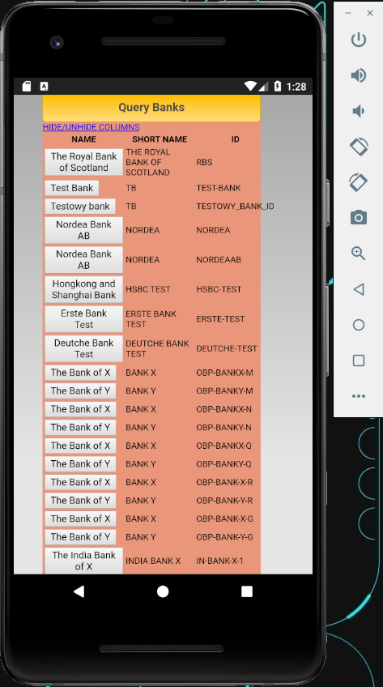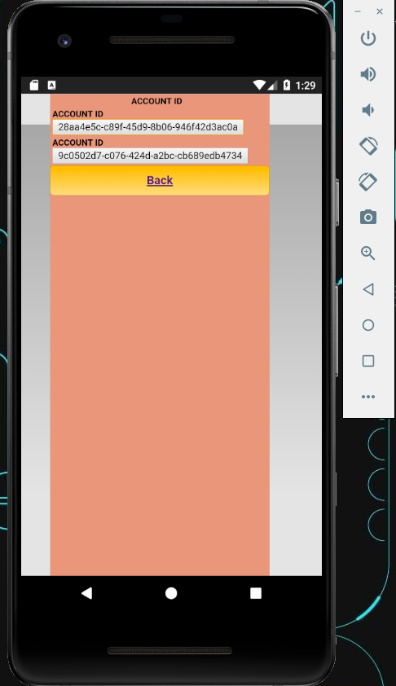

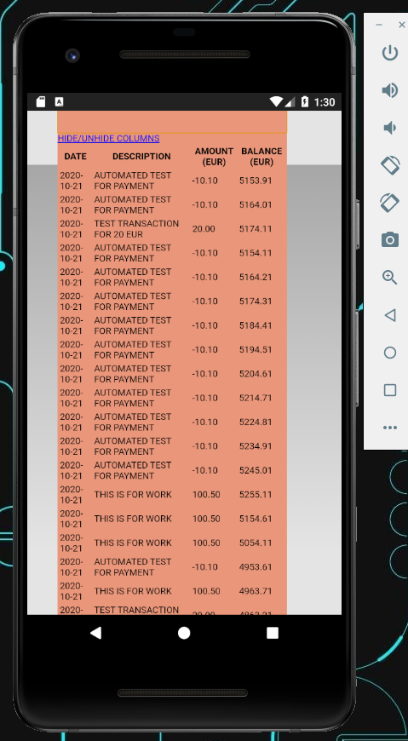

CMD LOG

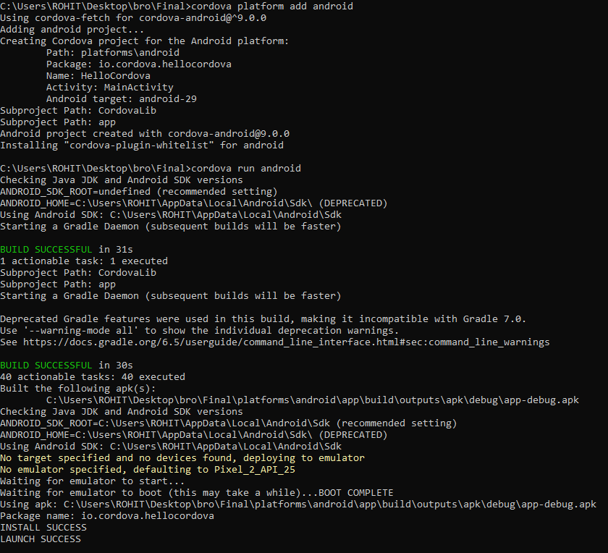

**Conclusion:**

In conclusion, In this field continuous improvement is going on. The best suggestion for developer is to understand technical requirements and gather all the information about project there advantages and disadvantages after this decide which platform is good for project moreover decide the framework too and language which is compatible for all the user globally which means that language is used for other platforms like android, IOS, Blackberry according to the Clint requirement also and In this tech field every programmer need to be up-to-date which means they never stop learning something new.

**Reference:**

CROSS PLATFORM MOBILE APPLICATIONDEVELOPMENT

http://www.ir.juit.ac.in:8080/jspui/bitstream/123456789/22962/1/CROSS%20PLATFORM%20MOBILE%20APPLICATION%20DEVELOPMENT.pdf

**Code Snippet**

**JavaScript**



**HTML**



**CSS**



**Complete Project**

